The Process of Committed Action
Creating an Ever-Enlarging, Upward Spiral
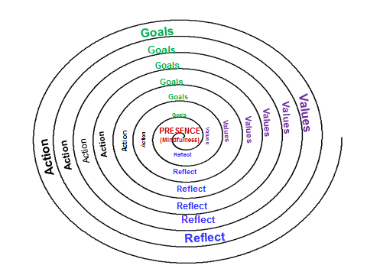
- Dr Kingsley Mudd MBBS FRACGP

- Choose a domain of life that is a high priority for change (e.g. work, education, relationships, family, leisure & recreation, health, personal growth, spirituality, etc)

- Reflect & learn from previous experiences in this area of your life.

- Clarify &/or review your values

- Set SMART goals (specific, meaningful, adaptive , realistic , time-framed)

- Immediate (next 24hrs)

- Short-term

- Medium term

- Long-term

- Take action (then repeat from step 2)
Remember : keep using your mindfulness skills to stay present and engaged at each step of the process !
Ref : “The Happiness Trap” and “ACT Made Simple” by Dr Russ Harris MD

Overcoming Obtacles
- Dr Kingsley Mudd MBBS FRACGP

Life is bit like running a hurdles race ; we regularly encounter obstacles that need to be overcome if we are to create the kind of life we truly want.
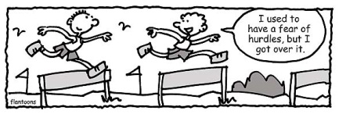
What barriers might prevent you from achieving your goals and how might you overcome these hurdles??
Barriers | Strategies for overcoming barriers.
Difficult Thoughts?

Difficult Feelings?

Lack of motivation?
(lack of clarity re values?)

Excessive or unrealistic goals?

Health problems?

Lack of time?

Financial or other material constraints?

Lack of skills?

Are their benefits in staying ‘stuck’ rather than moving forward?

Ref : “The Happiness Trap” and “ACT Made Simple” by Dr Russ Harris MD

